|  |  |
| --- | --- |
|  | **WEEKEND GOLDMINERS Newsletter**  ***Prospecting sites in the Heart of Georgia’s Gold Belt*** |
| **Established 1994** |

**Calendar of Events**

**May 7, 2022:**

**Metal Detecting Hunt: 12:00 PM**

**Board meeting: 3:00 PM**

**General Meeting: 5:00 PM**

**Held at Auraria Community Center, 4125 Auraria Road, Dawsonville, GA 30534**

**Do NOT metal detect here any other dates!**

**Last metal detecting of the year! Men MUST wear a dress for Mother’s Day to participate.**

**Keep July/August in mind for a Commons Dredge at Allison**

**Election of Officers in August**

**Any and ALL changes to Bylaws will be included with mail in ballot. Any suggestions or changes, submit to Ann Nemeth ASAP**

**Officers and Committees**

|  |  |  |  |
| --- | --- | --- | --- |
| **OFFICERS** | | | |
|  |  | | |
| **President** | **Rodney Kocher 813-924-8403 o2binbed@aol.com** | | |
| **Vice President** | **Barbara Lawson 706-864-1044 / 706-531-4062**  **lawsonb1947@gmail.com** | | |
| **Secretary** | **Heidi Lung 352-777-0075 Hlung1225@outlook.com** | | |
| **Treasurer** | **Ann Nemeth 740-294-1358**  **rcart4@hotmail.com** | | |
|  |  | |  |
| **BOARD OF DIRECTORS** | | | |
| **Member** | | **Robert Samples 770-374-8026 Samplesr88@gmail.com** | |
| **Member** | | **Randall Cowart** | |
| **Member** | | **Rodney Lung 352-531-9346 lungster67@yahoo.com** | |
| **Member** | | **Celeste Wilkerson 706-265-5293**  **armydragonwidow@yahoo.com** | |
|  | |  | |
| **WEGM Aux** | |  | |
| **Membership** | | **Rodney Lung 770-531-9346** weekendgoldminers@yahoo.com | |
| **Newsletter Editor** | | **Ann Nemeth** | |
| **Huntmaster** | | **John Burton** | |
| **WEGM Agent** | | **Ray Sparks** | |

**MAIL DUES TO:**

WEGM  
P.O. Box 910

Dahlonega, GA 30533

**PLEASE INCLUDE YOUR  
MEMBER # ON YOUR CHECK**

**WE ALSO NOW ACCEPT ZELLE PAYMENTS**

**Send to rcart4@hotmail.com**

**Check WEGM Website and Facebook group for more updates and announcements.**

**Drawings**

**Red ticket door prize:**

Silver round # 0589 Robert Samples

**Blue tickets**

Bag of Ore # 3668 William Simmons

Bag of ore # Rodney Kocher

Bag of ore # 3615 Dana Cowart

$50.00 Crisson Gift Card #3668 William Simmons

Gold Pan #1775 Kathy McCary

**Green tickets**

Bag of ore # 3615 Dana Cowart

Bag of ore # 3549 Jodi

Bag of ore #3668 William Simmons

$50.00 Gift Cert # 4301 Paul Jones

**Yellow tickets**

Bag of ore # 3204 David Griffin

Bag of ore # Mary Kazak

Bag of ore # 2342 Celeste Wilkerson

$50.00 Gift Cert #2267 Ben Tighe

Gold Pan # 3615 Randall Cowart

Copper round # 3615 Randall Cowart

Bumper Stickers #3478 Christina Priddy

**From The Desk of Vice President Barbara Lawson**

**I can see so much improvement in our club. Yes, mistakes have been made, but they also have been corrected too.**

**We were on the bottom, but now we are going UP. We will keep going up, by all the good work people have done.**

**Thanks to Ann, Heidi, and the board of directors, we are coming back. -- Also to the members that have had a positive attitude.**

**As the old saying goes “We Are Back”**

**WEGM is coming back. Think positive—NOT negative.**

**God Bless All!**

**Barbara Lawson**

**SALES**

**The FOR SALE section is free for members only.**

Dredge and Highbanker Combo $1300

Contact: Serena Welch (#2466) 706-344-7588

Membership For Sale $1300

Contact: Leona Welch (#3084) 678-523-6116

These are the new WEGM T-shirts for the men and ladies. All shirts are $10.00 ea. There will be a $6.50 shipping and handling charge for each shirt. If you want to place an order please state the color and size of shirt and how many. Send your order to: T-Shirt Order. P.O. Box 910, Dahlonega, Ga. 30533. Make check or money order to Weekend Gold Miners Club.

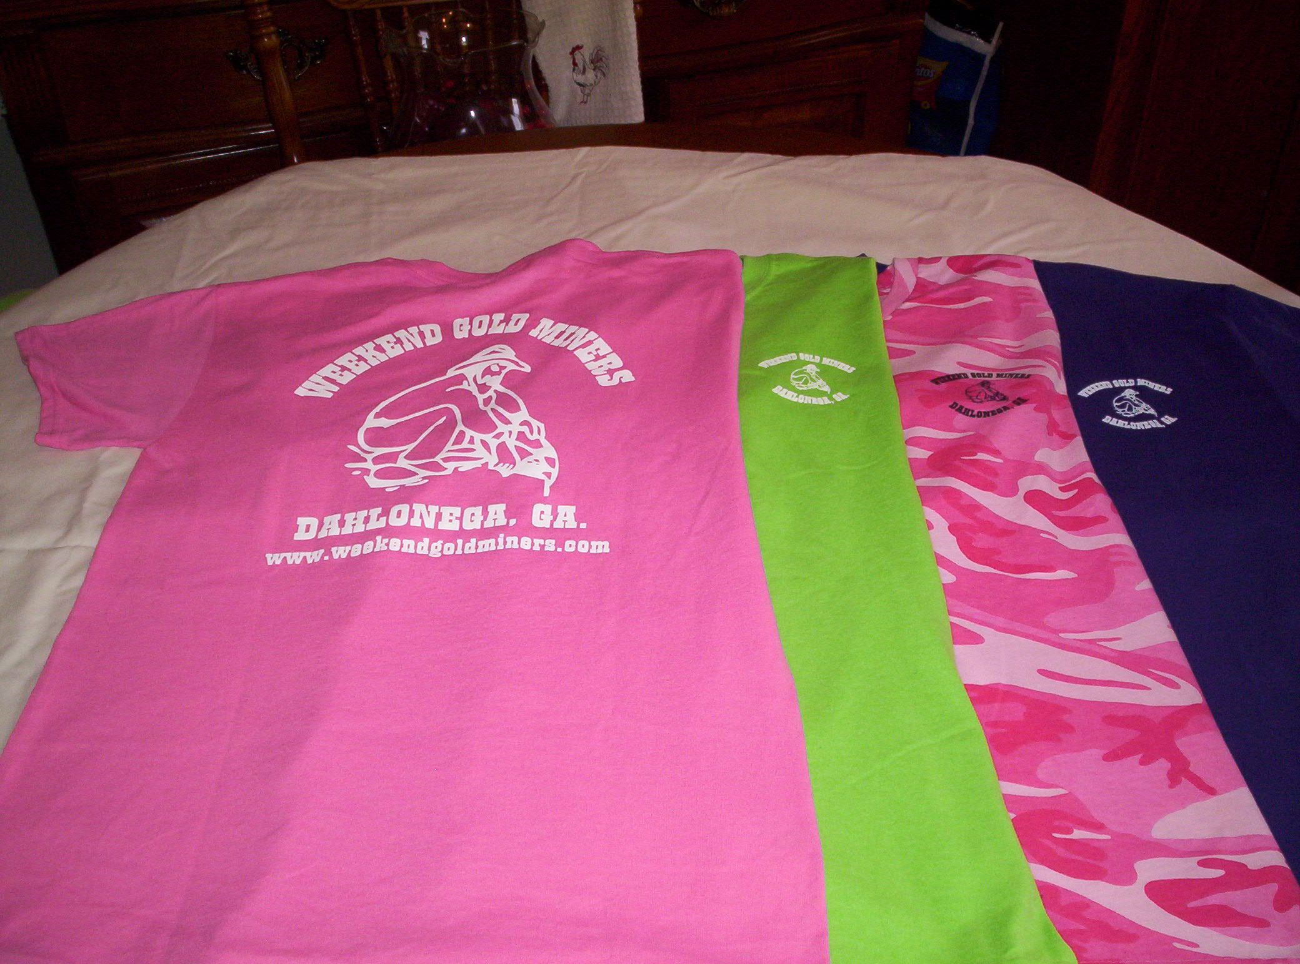

Ladies Shirt Colors: Pink, Green, Purple and Pink Camo.

Sizes: Small, Med., Large, X-Large and 2X.

Ladies shirts do not have a pocket.

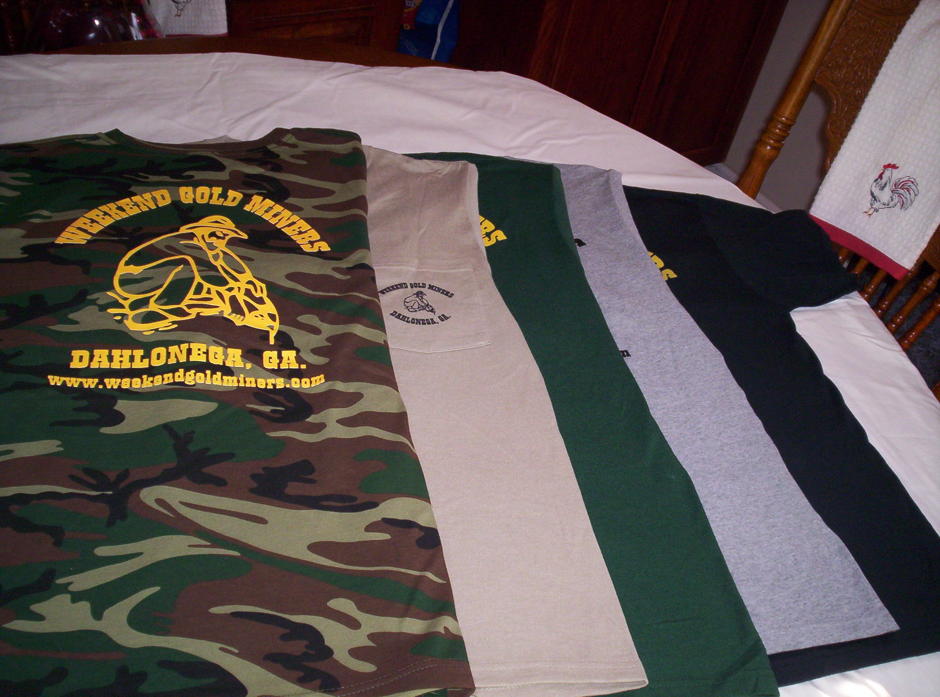

Men’s Shirt Colors: Black, Tan, Grey, Hunter Green, Camo

Sizes: Small, Med., Large, X-Large, 2X.

Camo shirts do not have a pocket.

**STANDING RULES**

1. No use of alcohol on Association outings.
2. Smoking will not be permitted at Association meetings or activities unless held in the open air.
3. Members are expected to adhere to the Association’s Code of Ethics while prospecting or mining
4. Members are expected to conduct themselves at all times in accordance with the laws of the land and reasonable moral behavior
5. Violation of Standing Rules will result in disciplinary action as determined by the Executive Board of Directors
6. The President, Vice-President or their appointed spokesperson(s) are the only people authorized to speak on behalf of the WEGM
7. Regular monthly meetings will be held on the first Saturday of each month at a scheduled time as stated in the club newsletter and website
8. Fun must be had by all

WEEKEND GOLD MINERS PROSPECTING CLUB, INC.

**GENERAL MEETING –** April 02**, 2022**

President Rodney Kocher called the April 03, 2022, General meeting to order.

No new members or guest present

Birthdays for April: Barbara Lawson 75 yrs. on 4/15, Celeste Wilkerson 4/16, Larry Brambalow 76yrs.

Condolences to the families of George Crappy & Kenneth Cherry. We were notified this week of their passing.

#1775 Alan McCary made motion to accept March 2022 General Meeting minutes as posted in the newsletter. #3478 Christina Priddy seconded. Motion passed and carried.

**Treasurer report given by Ann Nemeth for March 2022:**

Beg Bal…. ………...$20,028.40

Income……………..$12,698.23

Disbursed………….$911.55

End Bal…………….. $31,814.68

Savings account…$895.47

Transferred 4/2/22 $15,000.00 bank to savings account.

#2610 Ray Sparks made motion to approve treasurer report, #3478 Christina Priddy. Seconded. Motion passed and carried.

**Membership Report: Rodney Lung gave March,2022 report as follows:**

New members 5

New members YTD 14

Transfers 0

Last # 3675

Total new membership fees $2,150

Logo items $0 Total Collected $2,150

A special thanks to Tammy & Tony Ray for selling memberships at Crisson.

#2890 Barbara Lawson made motion to accept the March membership report. #0589 Robert Samples second motion passed and carried.

**OLD BUISNESS**

Locks have been changed.

Thanks to Robert & Jeremy Samples for filling in potholes on Turner. Also, thank you to those who helped at the school. Heidi Lung & Ann Nemeth did a presentation on gemstones. Rodney Lung demonstrated panning, Ray Sparks showed gold and explained high banking. Nancy Healy and Rodney Kocher were also there to assist.

Common Dig April 9th. This is an old fashion dig bring your buckets, shovels, and any equipment

you are willing to share for the day. We will have gems and metal detecting. #1290 Joyce Conner and #3517 Mary Kozak made donations for the gems. Mr. Turner and his family will join us in the dig and will be providing chicken and BBQ. This is a potluck so bring a covered dish to share.

**NEW BUISNESS:**

Re-addressed visitors stay. A visitor can come two times in a year and stay a maximum of fourteen day in those 2 visits. After that they must join in order to revisit club. Whether they stay 5-days one time and three the next, that’s their two stays. Member must be with their visitors during their stay. **All visitors must be signed in on the back of your sign in sheet.**

The club has two new bumper stickers. They are on sale for $5.00 each. Sales will benefit replacing items lost in the fire. The club is looking into recycled tin for the picnic area instead of replacing the frame with a canopy. The canopies are not in the best shape and the tin roof will last years. As the club replaces items, we need a place to store them. Do we rent a storage unit at $100.00 a month or put up a temporary storage shed? Any ideas on this are welcome.

Auxiliary is planning a yard sale in June to also raise funds for replacing items. The date will depend on buildings availability. The club only received $2,000 from insurance company for the fire.

**Election Committee**: We need volunteers for a committee for the upcoming election in August.

**Commons Dredge:** Club is looking to have a commons dredge in either July or August at Allison. Date to be announced. As always commons are open to the public.

Due to the theft at Crisson, this time there are no nuggets; there are gift certificates.

#1290 Joyce Conner Made motion to Adjourn the meeting. #3242 Celeste Wilkerson seconded the motion. Meeting Adjourned

Next meeting May 7, 2022

Metal detecting 12:00pm

Board meeting 3:00pm

General meeting 5:00pm

Prepared by Heidi Lung WEGM Secretary